Celebration of the life well lived by
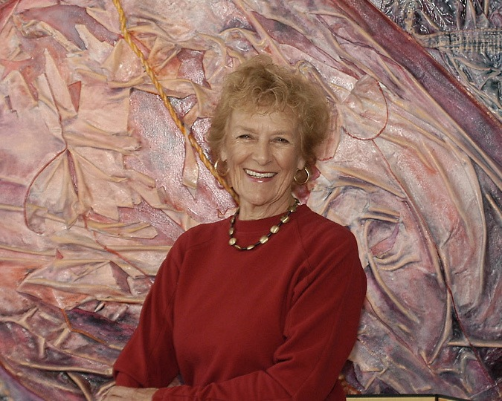Jeanne Aurel Schneider
May 12, 1930 – August 29, 2013

Painter, wife, mother, beloved friend…
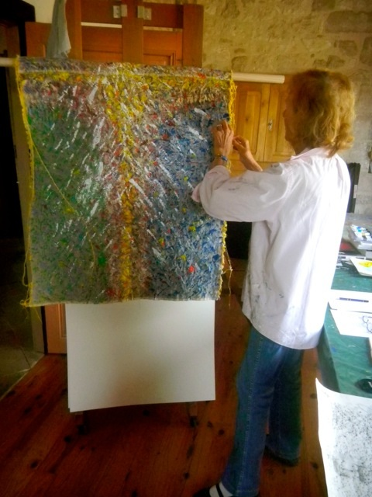 | 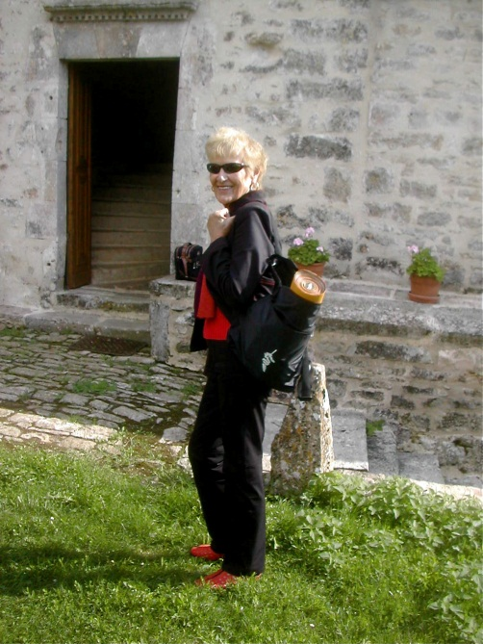
Painting “Celebration Rosieres-en-Haye June 2012 Homage to Freddie” at her studio at Lamothe | 2008-09(Sep) at Chateau de Marsa with the “Round the World Ribbon” painting

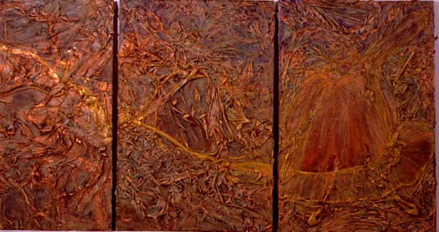
Painter’s Dance, mixed media collage

Funeral Mass for Jeanne Marie Aurel Schneider
Thursday, 5 September, 2013 at 1 pm
Saint Anne’s Church, 1600 Rossmoor Pkwy, Walnut Creek

Priest: Father Joseph Parekkatt

First Reading – Wisdom 3:1-9 read by Frederick Aurel Schneider
Second Reading – 2 Corinthians 4:14-5:1 read by Leo Martin Schneider
Gospel – John 12:23-28 read by Father Joseph
After Communion piano concerto by Chopin played by Marcos Cordoba Schneider
Eulogy: Poem by Catherine Schneider read by Wayne Raynal Lewis and message to all by John Frederick Schneider

Reception following is at Creekside Clubhouse, Meeting Rooms 1 & 2, 1010 Stanley Dollar Dr., Walnut Creek, CA (925)954-1063

Directions from St Anne's Catholic Church to Creekside Clubhouse:
 | ‎
 | 1. | Head northeast on Rossmoor Pkwy

 | 2. | Make a U-turn  About 3 mins | go 0.9 mi  total 1.0 mi
 | 3. | Turn right onto Stanley Dollar Dr  Destination will be on the right |  |  | go 295 ft  total 1.0 mi

‎

