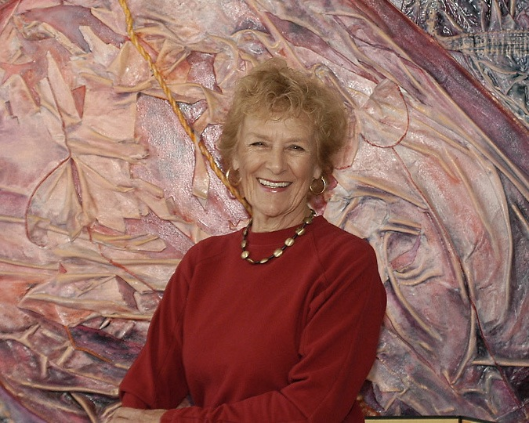
Picture taken by Rossmoor News 2007 for an article on Jeanne

Jeanne Marie Aurel Schneider, Age 83
Born: 12 May 1930 in San Francisco, California
Died: 29 August 2013 in Walnut Creek, California

Jeanne Aurel Schneider, 83 – devoted wife, mother, grandmother, artist, cook and writer - died on August 29th in Walnut Creek of lung cancer. Jeanne was born to French immigrants, Fernand and Therese Aurel, in San Francisco on May 12th 1930. She is survived by her beloved husband, Donald, 4 children and their spouses, and 5 grandchildren: daughter Catherine (61) and her husband Peter and grandson Wayne (26) of New York; son John (60), his wife Jill and their children Bennett (19) and Margot (16) of Canberra, Australia; son Frederick (55) and his wife Pat of San Jose, CA; and Martin (53), his wife Lorena and their children Leo (19) and Marcos (16) of Santa Barbara, CA).

Jeanne grew up in San Francisco and Burlingame, graduating from Burlingame High School as Valedictorian in 1947. She attended Mills College in Oakland, graduating Magna Cum Laude in 1951. She married Donald Schneider, also of Burlingame, in 1951, and from 1956 settled in San Jose to raise their family. Jeanne began to realise her passion for art in the late 1960s when she returned to college at San Jose State University, receiving her Master’s Degree in Fine Art in 1973. In 1977 Jeanne started the Children’s Art School at the San Jose Museum of Art, which she also ran for five years. Her early art work was in graphite and watercolor, very precise and controlled, yet sensual and evocative. She later developed a technique for embedding treasured clothing and other items into handmade paper to enter into the third dimension and to allow the clothing to express the human emotion and personality of its former owner. She often expressed personal feelings in her paintings, using art to convey her emotions: the pain of family tragedies, the joys of birth, the awesomeness of nature. Her latest work used a combination of materials to create landscapes on unstretched linen and antique cloth, drawing from her emotions to bring personal meaning to the images, and encouraging them to crinkle and fold into the third dimension. Jeanne exhibited her work throughout the US, in Europe, Australia, and, in 2012, in Beijing, China; her work lives on in galleries and private collections throughout the world.

Jeanne, whose first language was French, realised her life-long dream to live in France, when, in 1995, she and Don purchased a 17th century stone house at Lamothe in Saint Cecile du Cayrou, near Toulouse in southern France. They spent their remaining 18 years together dividing their time between summers at Lamothe and winters in the San Francisco Bay Area, while travelling the world visiting their far-flung family and friends throughout the world. During this time, Jeanne re-established her roots in France, often bringing her extended French family and friends together for a fabulous French country meal at Lamothe. She continued her painting at her Lamothe studio and cultivated a beautiful garden of roses and seasonal vegetables, widely enjoyed by the local community. She wrote a cook book, “Jeanne Marie’s Kitchen’, in honor of her mother Therese, and in the past year, another book, “My Brother Freddie”, as a memorial to her brother who died in 1958, age 24, as a US Air Force pilot in Toul, France. In her final days, she was still writing, this time, a compilation of letters from her Great Uncle Frederic who was a priest in the Belgian Congo in the first half of the 20th century.

Jeanne was equally passionate and loving as wife, mother, and friend, as she was as painter, teacher, cook, gardener and author. These were never separated from one another. Her devotion to family and friends gained intensity and gave meaning to her creative expressions. There was always a connection between creation and emotion. She was not a mother who painted, or a painter who was also a mother; each role augmented and gave meaning to the other. But this did not come without its obstacles, from being strongly discouraged as a child by her father for using her left hand to draw, to the Chairman of the Art Department of San Jose State University refusing to sign her application to graduate school. In the male dominated world of fine arts, he believed she should be home with her children, despite her perfect academic record. Of course, none of these deterrents was sufficient; rather they only served to increase her resolve to succeed.

Jeanne, Mom, Ma Jeanne (to her grandchildren) will be greatly missed for her love, her passion, her wisdom, and her ability to connect people with each other. She will remain forever in our hearts and in every creative endeavour that we do.

Schneider Family
3 September 2013

Here is a link to her professional website, which has images of her paintings, her resume, and a description of her philosophy as an artist: http://atelieraurel.homestead.com/

